FINANCIAL PERFORMANCE & PROFITABILITY ANALYSIS DASHBOARD

1. Project Title
Financial Performance & Profitability Analysis Dashboard Using Microsoft Excel and Power BI

2. Abstract
The Financial Performance & Profitability Analysis Dashboard is a data analytics project developed using Microsoft Excel and Microsoft Power BI. The main objective of this project is to analyze an organization's financial performance by examining revenue, expenses, profit, profit margins, and budget variations.
The project transforms financial transaction data into meaningful visual insights through interactive charts, KPI cards, and slicers. It helps users understand financial trends, compare actual performance with budgeted values, identify profitable departments, and support better business decisions.

3. Introduction
Financial analysis plays an important role in understanding the performance of an organization. Businesses generate large amounts of financial data, making it difficult to identify important trends through raw tables.
This project uses Excel for organizing financial data and Power BI for creating an interactive dashboard. The dashboard presents important financial information in a simple visual format, allowing users to monitor performance and make informed decisions.

4. Problem Statement
Organizations need an effective way to monitor revenue, expenses, profitability, and budget performance.
Analyzing financial information manually can be time-consuming and may make it difficult to identify trends and differences between actual and planned performance.
Therefore, this project aims to develop an interactive financial dashboard that simplifies financial analysis and improves decision-making.

5. Objectives
Analyze total revenue, expenses, and profit.
Calculate overall profit margin.
Monitor monthly financial performance.
Compare actual revenue with budgeted revenue.
Compare actual expenses with budgeted expenses.
Analyze profit across different departments.
Identify revenue variations.
Provide interactive financial insights using Power BI.

6. Tools and Technologies Used
Tool | Purpose
Microsoft Excel | Data organization and preparation
Microsoft Power BI Desktop | Dashboard creation and visualization
DAX | Creating calculated measures
Charts and KPI Cards | Presenting financial insights
Slicers | Interactive filtering

7. Dataset Description
The project uses a financial dataset containing transaction-related information.
The dataset includes the following fields:
Column | Description
Date | Date of financial transaction
Department | Department associated with the transaction
Category | Financial transaction category
Revenue | Income generated
Expenses | Money spent
Profit | Difference between revenue and expenses
Profit_Margin | Profit as a percentage of revenue
Budget_Revenue | Planned revenue
Budget_Expenses | Planned expenses
Revenue_Variance | Difference between actual and budgeted revenue

8. Methodology
The project was developed through the following stages:

Step 1: Data Collection
Financial transaction data was collected and organized in Microsoft Excel.

Step 2: Data Preparation
The dataset was checked and arranged into a structured table. Financial columns were organized for further analysis.

Step 3: Data Import
The prepared Excel dataset was imported into Power BI Desktop.

Step 4: Data Analysis
Financial measures were created to calculate total revenue, total expenses, total profit, and overall profit margin.

Step 5: Dashboard Development
Charts, KPI cards, and slicers were added to create an interactive dashboard.

Step 6: Testing
The Month and Department slicers were tested to confirm that the dashboard visuals respond to user selections.

9. Key Financial Measures
The following DAX measures were used:
Total Revenue
Total Revenue = SUM(Table1[Revenue])
Total Expenses
Total Expenses = SUM(Table1[Expenses])

Total Profit
Total Profit = SUM(Table1[Profit])
Overall Profit Margin
Overall Profit Margin =
DIVIDE(
SUM(Table1[Profit]),
SUM(Table1[Revenue]),
0
)
Profit Margin is calculated as:
Profit Margin = (Profit / Revenue) × 100

10. Dashboard Components
The dashboard contains the following visualizations:
Total Revenue KPI Card: Displays the total revenue generated.
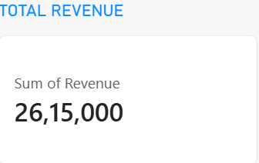
Total Expenses KPI Card: Displays the total expenses incurred.
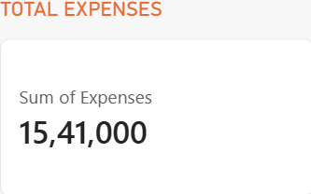
Total Profit KPI Card: Displays the overall profit.
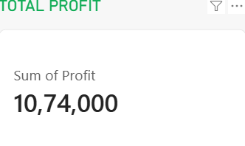
Overall Profit Margin KPI Card: Displays profitability as a percentage.
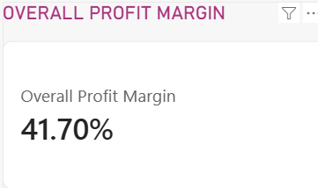

Monthly Revenue Trend: Shows changes in revenue over time.
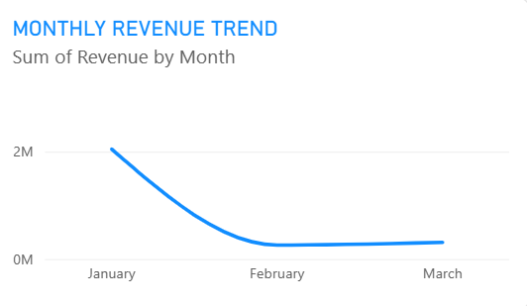
Monthly Expenses Trend: Displays monthly expenses.
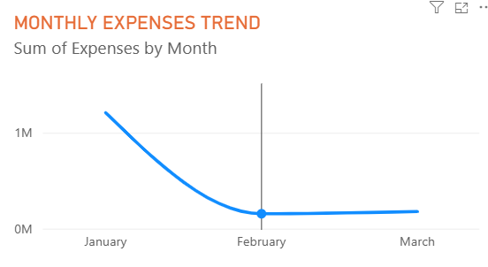
Monthly Profit Trend: Shows monthly profit performance.
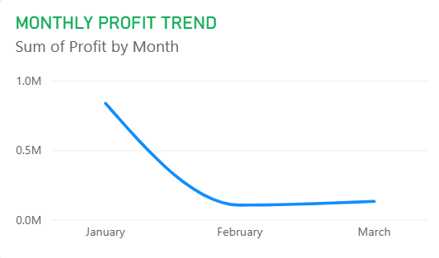
Department-wise Profit Analysis: Compares profitability across departments.
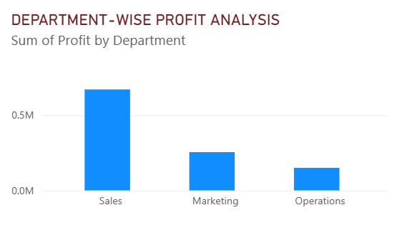
Budget vs Actual Revenue: Compares actual revenue with planned revenue.
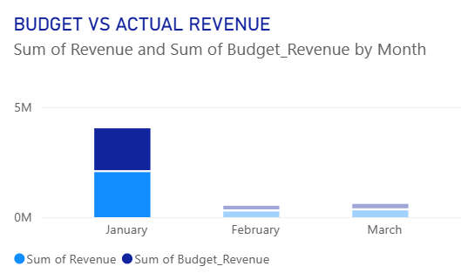
Budget vs Actual Expenses: Compares actual expenses with planned expenses.
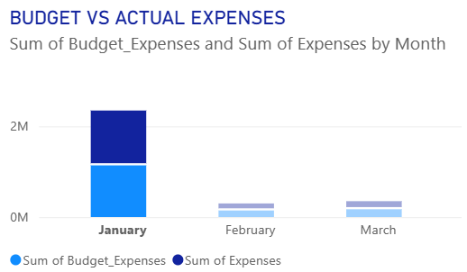
Monthly Revenue Variance Analysis: Highlights differences between actual and budgeted revenue.
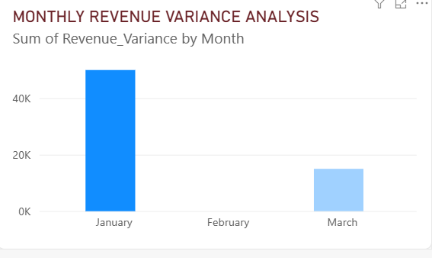
Month and Department Slicers: Allow users to filter dashboard information interactively.
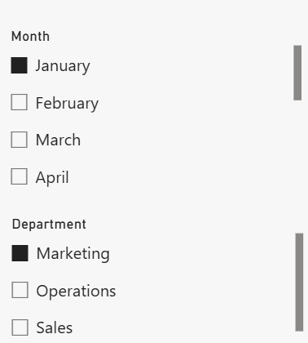

11. DAX and Analytical Concepts
The project uses basic DAX functions and analytical concepts:
SUM(): Calculates the total of a numeric column.
DIVIDE(): Performs division safely and handles division by zero.
KPI Analysis: Measures important financial indicators.
Trend Analysis: Examines changes in financial performance over time.
Variance Analysis: Compares actual results with planned values.

12. Results and Outcomes
The developed dashboard provides a consolidated view of financial performance.
The project enables users to:
Monitor important financial indicators.
Understand monthly revenue and expense trends.
Identify profitable departments.
Compare actual and budgeted financial performance.
Analyze revenue variations.
Filter financial information by month and department.
The interactive dashboard makes financial information easier to understand and supports data-driven decision-making.

13. Advantages
Easy-to-understand visual representation.
Reduces manual financial analysis.
Provides interactive filtering.
Helps monitor profitability.
Supports budget comparison.
Improves financial reporting.

14. Limitations
Dashboard accuracy depends on the quality of the input dataset.
The current project uses a prepared financial dataset.
Advanced forecasting and predictive analytics are not included.
The dashboard needs updated data to reflect new financial transactions.

15. Future Enhancements
The project can be improved by adding:
Real-time financial data integration.
Profit forecasting using machine learning.
Advanced expense analysis.
Automated financial reports.
Year-over-year performance comparisons.
Additional business performance indicators.

16. Conclusion
The Financial Performance & Profitability Analysis Dashboard demonstrates how Excel and Power BI can be used to transform financial data into meaningful business insights.
The project provides an interactive platform to monitor revenue, expenses, profit, profit margins, and budget performance. It also demonstrates practical skills in data preparation, financial analysis, DAX calculations, and dashboard development.
This project provides a foundation for further learning in Business Analytics, Financial Data Analytics, and Management Information Systems (MIS).

17. References
Microsoft Excel Documentation.
Microsoft Power BI Documentation.
Microsoft Learn – Power BI Learning Resources.
Microsoft Learn – Data Analysis Expressions (DAX).

